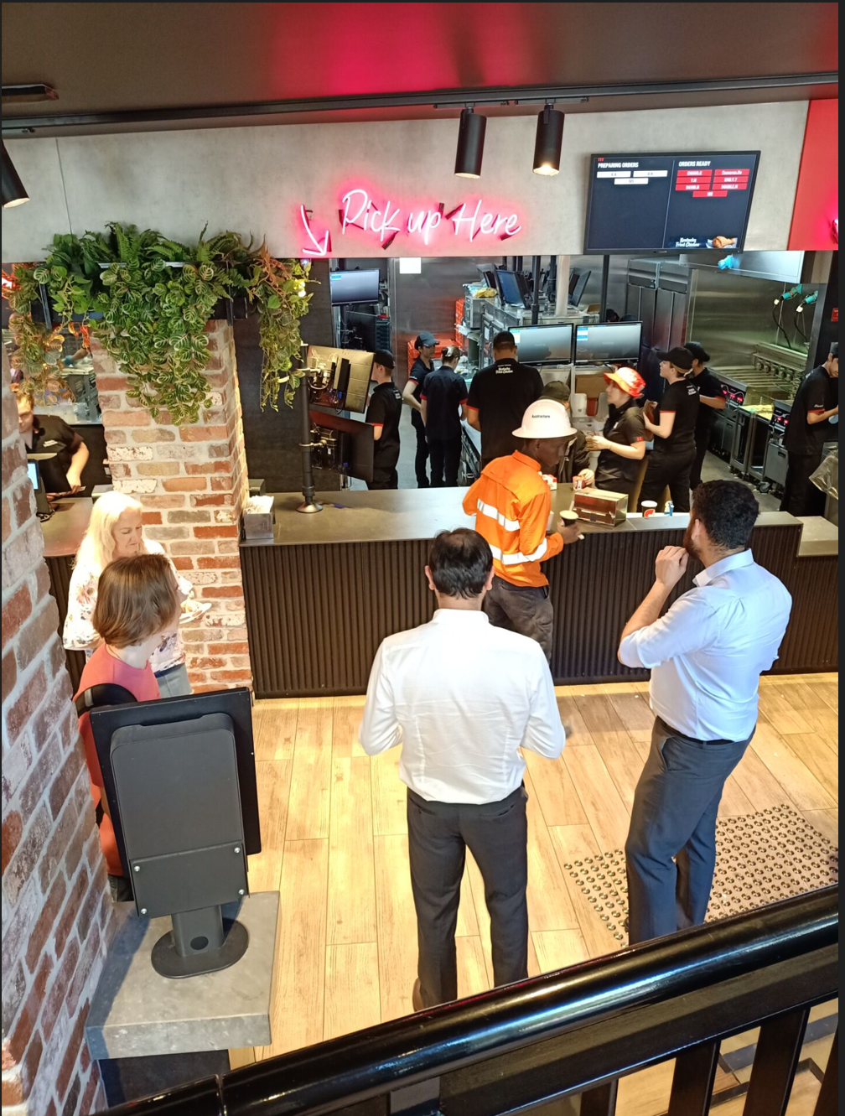

**Observation result**

I conducted the observation for about half an hour at a KFC in central Brisbane. During the observation period, I mainly observed the people who came to KFC to eat, the way they ate and the food they ordered. During the observation, I found that most of the people who come to KFC to eat are white-collar workers nearby. Most people prefer to take away rather than dine in KFC’s in-house restaurant. Most people choose a regular set meal.

During the observation, I only saw one construction worker coming to dine. He also ordered a regular set meal and chose to take it away to eat.